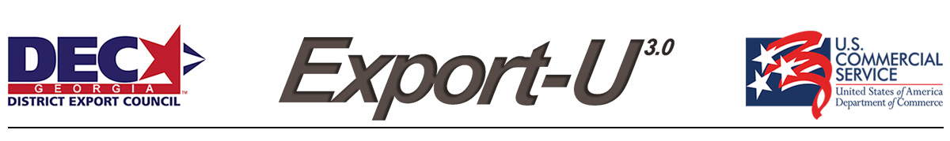
Website Globalization
We all know that websites are a
necessity for any business and an important sales and marketing tool. They say a lot about your organization and serve as a virtual introduction of your products and services. This holds true for both domestic and international sales.
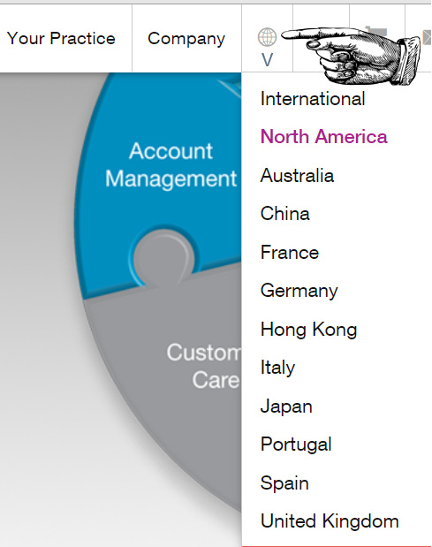
You probably have a “Contact Us” page making it convenient for customers to reach you. But, what happens when a potential overseas customer visits your site?
- Is there a link for international sales inquiries?
- What information should it require from your potential export customer?
- And, how does your site look like on a mobile device or when translated into a foreign language?
These are just a few of the questions every organization needs to consider when designing a website offering products or services internationally.
You might assume that this overview of website globalization will be focused on technical things like analytics and search engine optimization. Well, rest assured that’s is not the case --- so keep reading. This article just makes a few suggestions that anyone with a basic knowledge of websites can easily implement to attract more export sales.
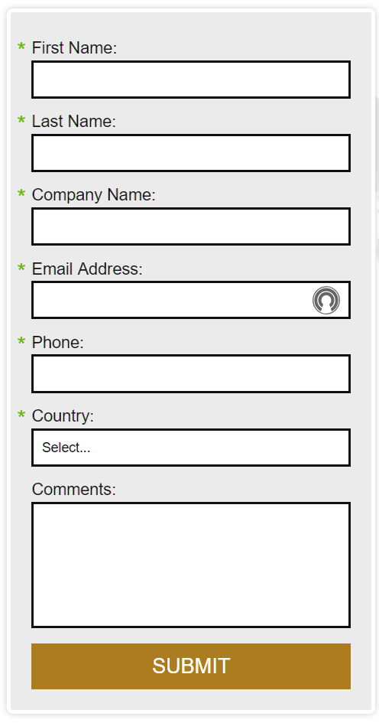
One fundamental suggestion is to make it obvious to foreign visitors that you welcome their business. This requires more than just adding an international-sales@company.com email address to your “Contact Us” page. While an international e-mail inquiry feature can be useful, we advise adding a specific page dedicated to “International Inquiries” with an international inquiries form. But be cautious, about how much information you are requesting; only require essential data. Also, ensure that certain information fields are not required which may not work for overseas customers. Zip codes and telephone numbers may have more or fewer digits than the US norm (i.e. 123-456-7890). Addresses and telephone numbers around the world are seldom in the same format as in America and the intake forms need to accommodate this variation. An open field text box is generally a good way to go.
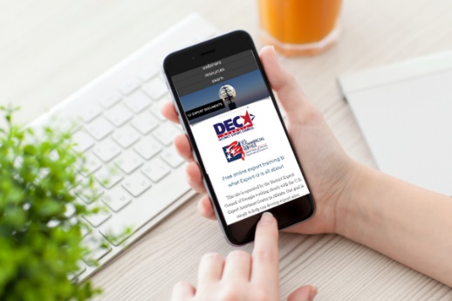
We also live in a world where mobile devices are now the predominant means for conducting e-Commerce. Today, 60% of international B2B and B2C commerce is via mobile devices. This means your web presence must be mobile compatible? Not only is it an important aspect for international business, it also makes sense for your domestic customers as well. Nothing is as frustrating for a customer as when trying to zoom in from their iPhone to a company’s webpage just to access basic contact information. Be sure and work with your website service provider to ensure mobile compatibility is enabled, works properly, and limited to the most important information.
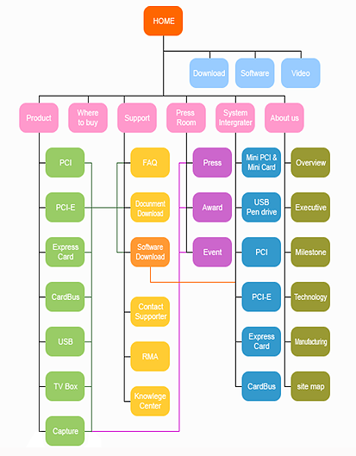
We all have our favorite search engine. Most of us use Google, a few of us use Bing, and there are probably a few hold outs that are still using Yahoo!. Regardless of the search engine that you use, does your company consider what search engines are being used internationally? Ever heard of Baidu, Yandex or Naver? If your sales team is trying to attract customers from China, Russia, or South Korea, then you need to have heard of these three. Baidu takes up 60% of all internet searches in China, with Yandex capturing 62% of the Russian market, and Naver with more than 70% of South Korean online searches. Yahoo! Japan and Yahoo! Taiwan are both the most popular searches in both of their respective markets. When targeting a specific market or region of the world, ensure that your company will be found when customers come looking.
Does your company’s webpage have a site map? If you’re response is, “what’s a site map?” you are probably not alone. A site map is an XML file that search engines use to “read” what is on your webpage and impacts where your company is listed on a search results page. If looking to grow your visibility internationally, it is important for your company to register the site map with the popular search engines used in the market. Site maps also exist as an HTML file and allow for quick navigation, an important aspect if that potential customer is in a developing marketing and accessing the internet on a pay-as-you-go basis.
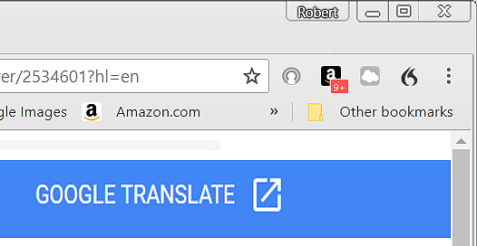
Companies may be tempted to translate their webpages to attract international customers. And while this is a completely logical idea, it is vital to employ a professional translation service. However, translation services can be an expensive investment, especially if you translate your entire site. We often recommend initially using a Google Translate plug-in link. It is a free downloadable app, and if mistakes are made, an international visitor will know these are due to the translation software and not your company. Finally, to make a good first impression, be certain that your site is free of any spelling or grammatical errors.
While these might seem like minor tweaks, they can make a huge difference to for potential export customers. For more advice on how to globalize your website for international business, contact your local U.S. Export Assistance Center. To find the nearest Center, visit: https://www.export.gov/locations.

